ELEC 2110

Electric Circuit Analysis

Gabriel Emerson

Jake Bryson

October 1, 2019

Section 002

Recitation, MATLAB, and MultiSim: First-Order Transient Circuits

Introduction

Students will solve four total circuits using the Transient Circuit method. Plot each circuit using MATLAB and MultiSim, and also draw the schematic to test the final answer.

Exercise 1

Given circuit 1, Calculate i0(t) for t > 0. Plot i0(t) versus time using MATLAB and include the plot in your report. Now simulate this circuit using MultiSim and plot i0(t) versus time.

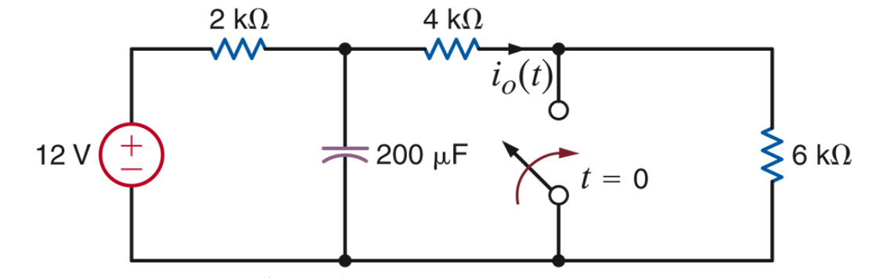

(1)

Circuit 1

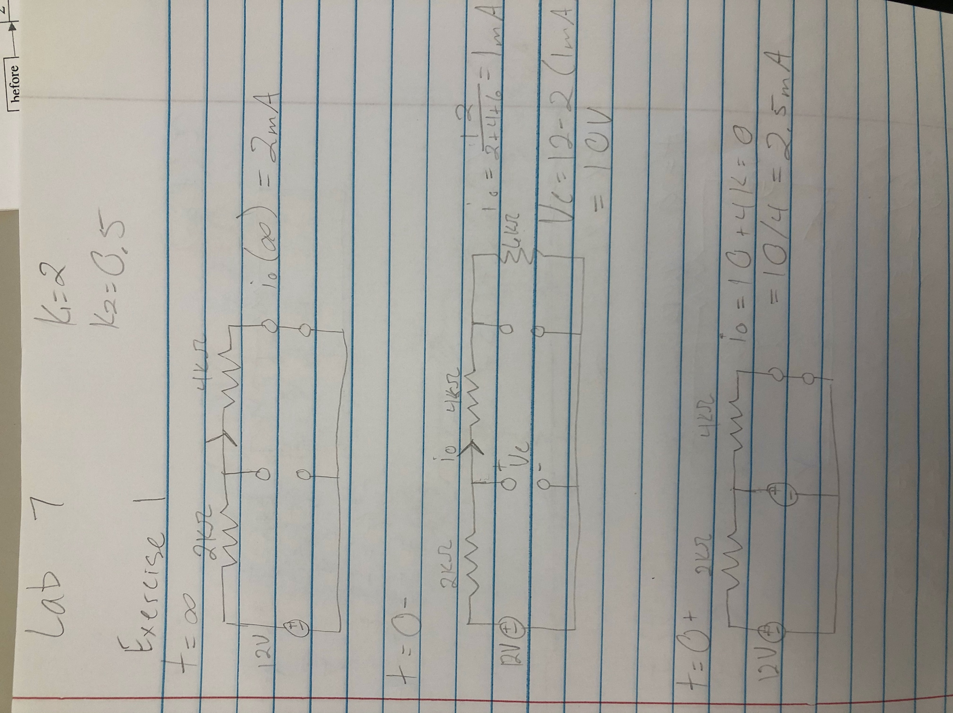

Equations for exercise 1 (2)

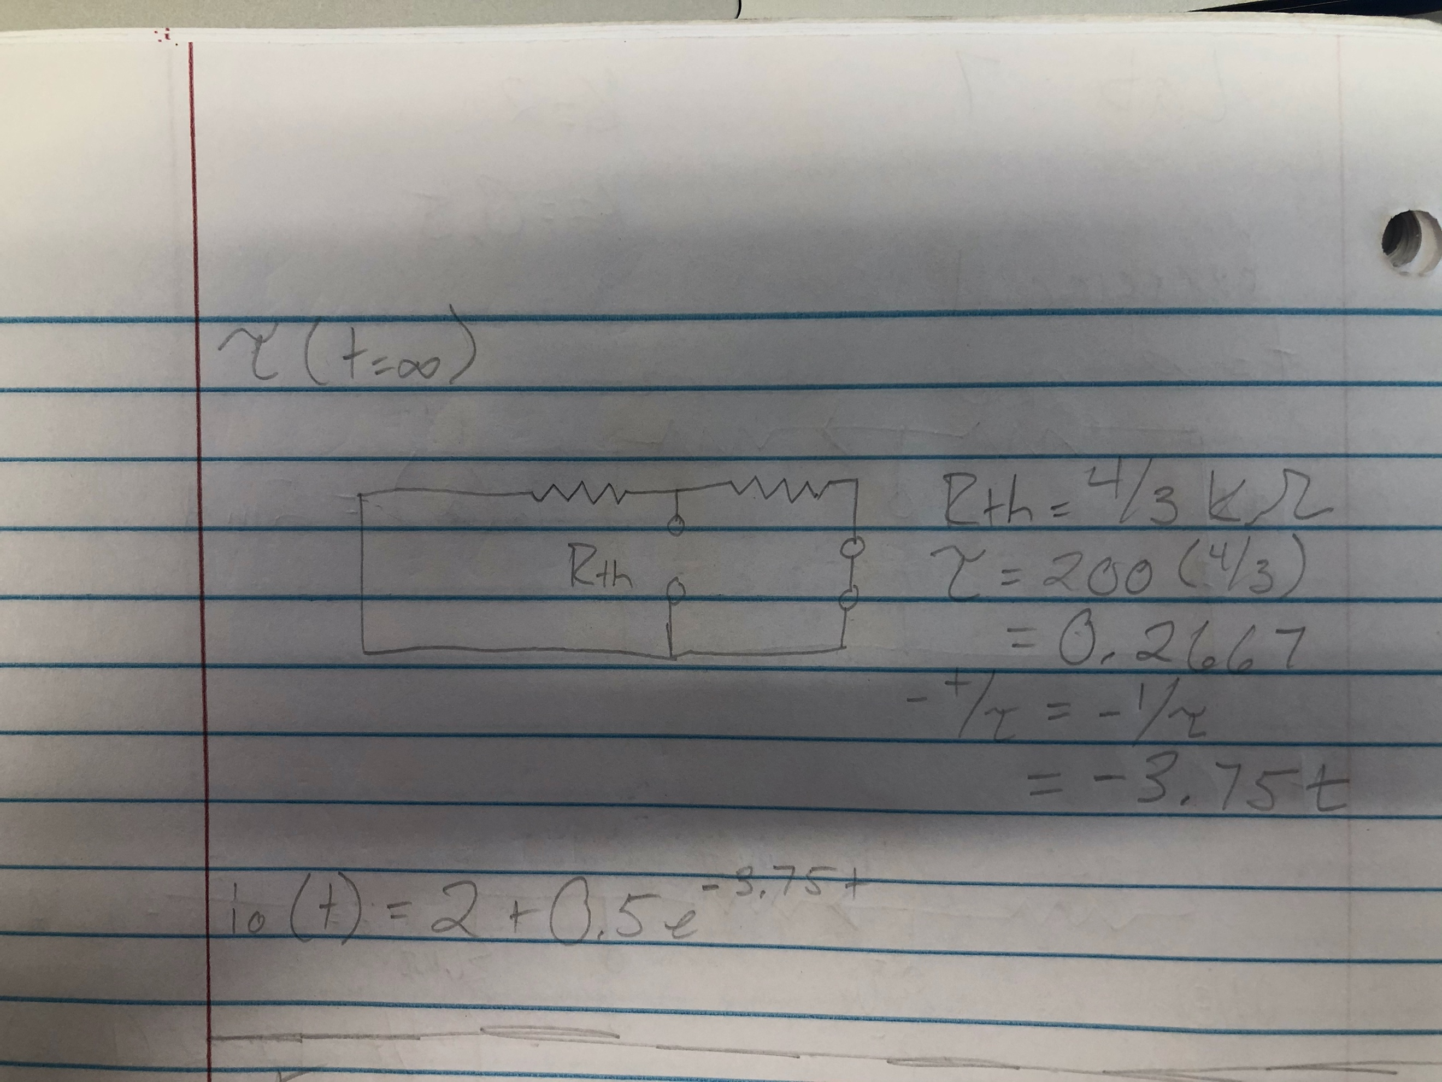

(3)

Equations continued

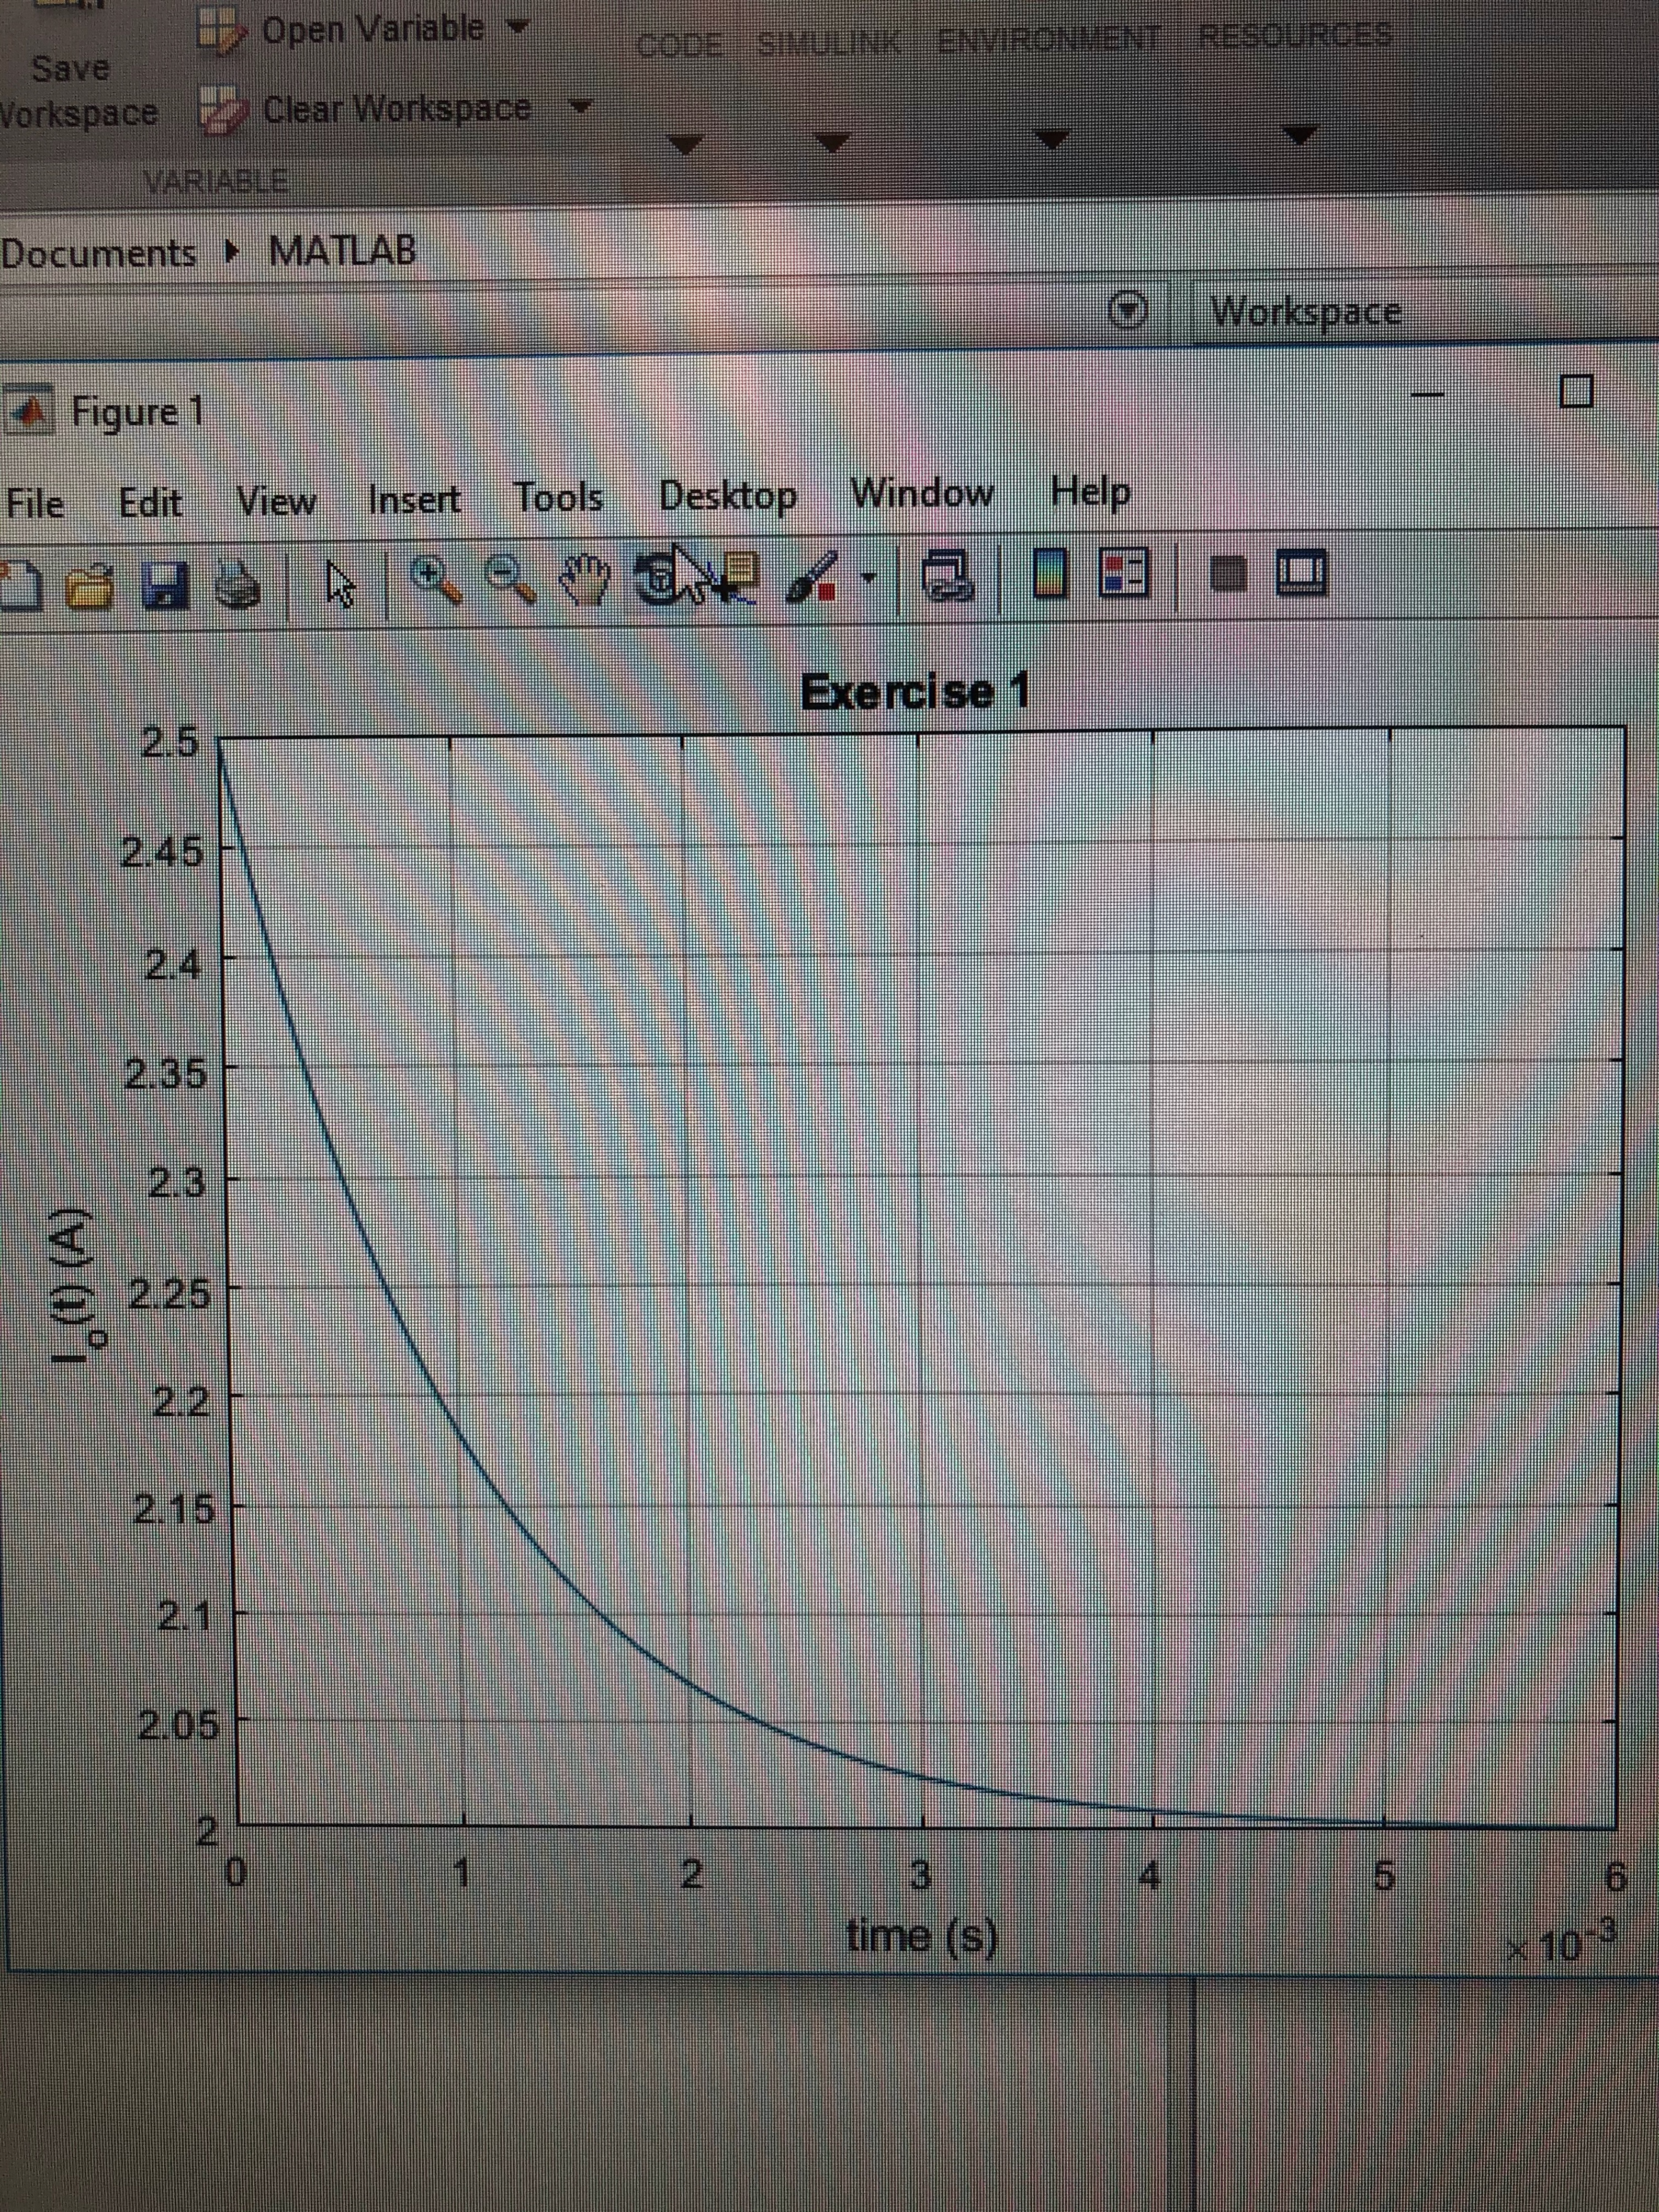

(4)

MATLAB plot

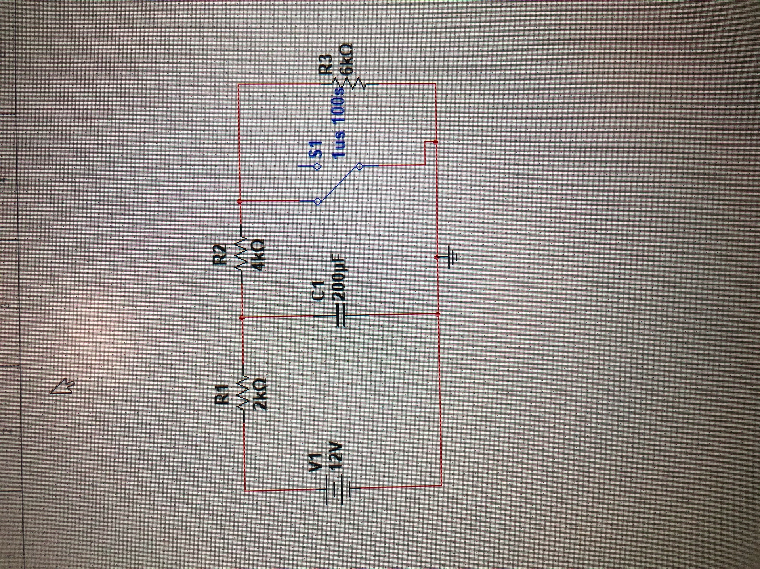

(5)

Schematic drawn in MultiSim

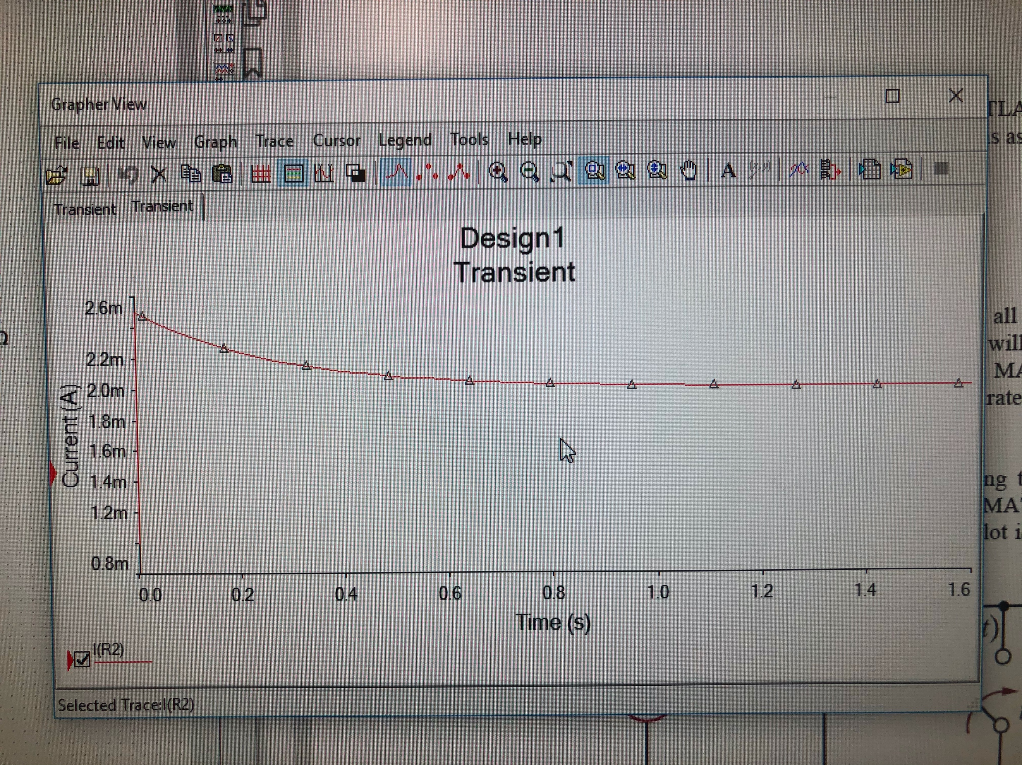

(6)

Graph in MultiSim

Summary Table

|  |  |
| --- | --- |
| K1 | 2.0mA |
| K2 (K1+K2=2.5) | 0.5mA |
| Rth | 4/3K Ohm |
| Tau | 0.2667 |
| -1/Tau | -3.75 |
| Io(t) | 2+0.5e^-3.75t (A) |

Exercise 2

Given circuit 2, Calculate i0(t) for t > 0. Plot i0(t) versus time using MATLAB and include the plot in your report. Now simulate this circuit using MultiSim and plot i0(t) versus time.

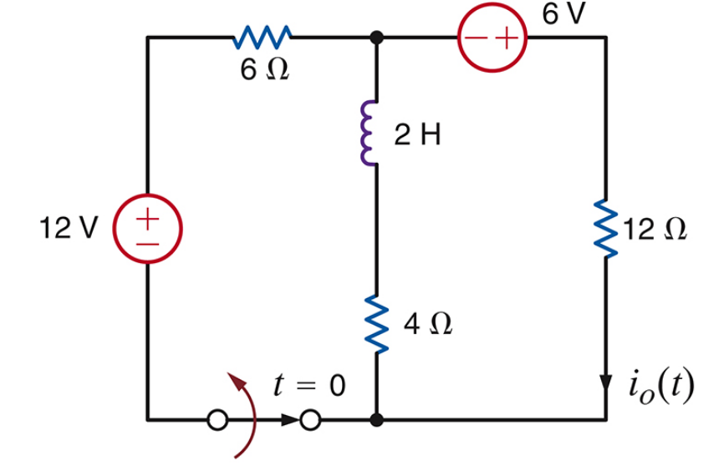

(7)

Circuit 2 for exercise 2

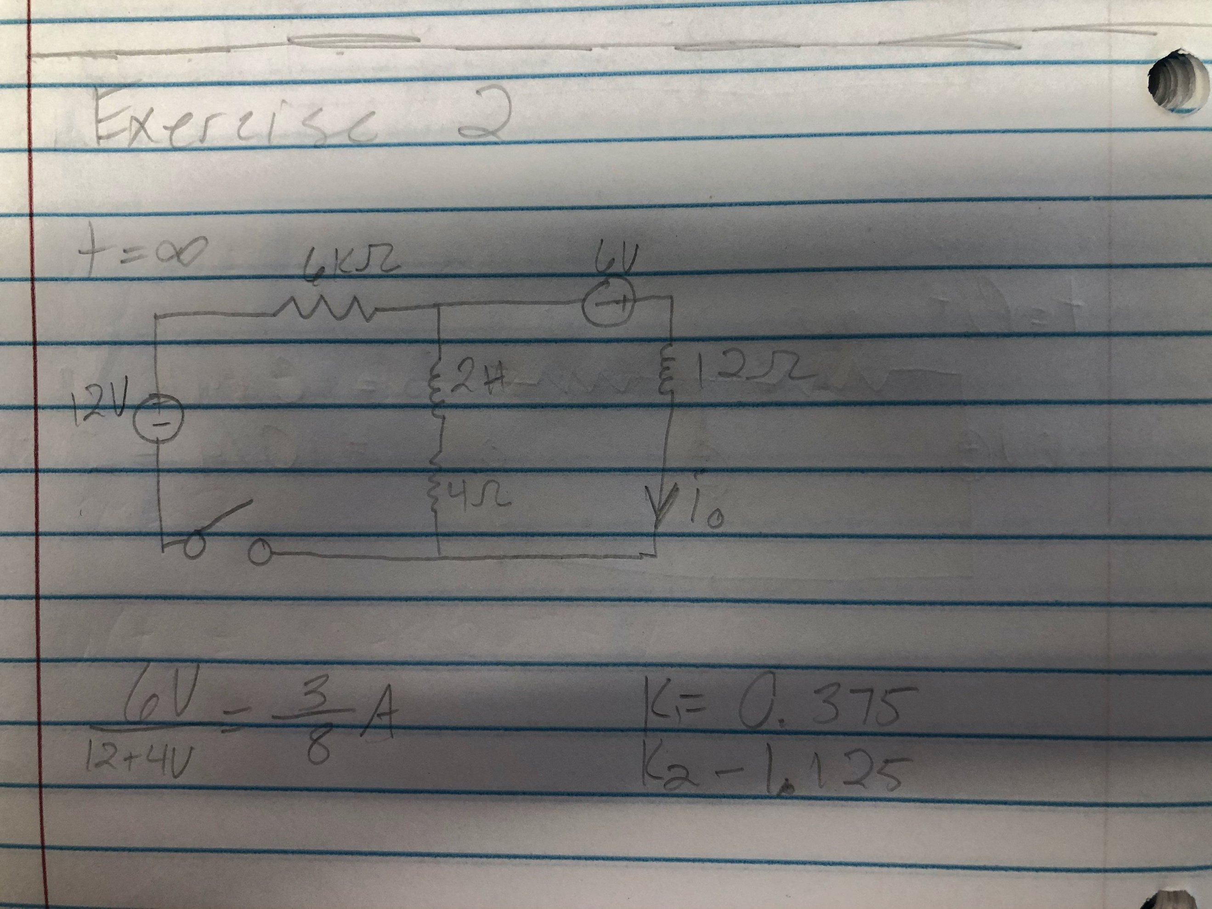

(8)

Equations for exercise 2

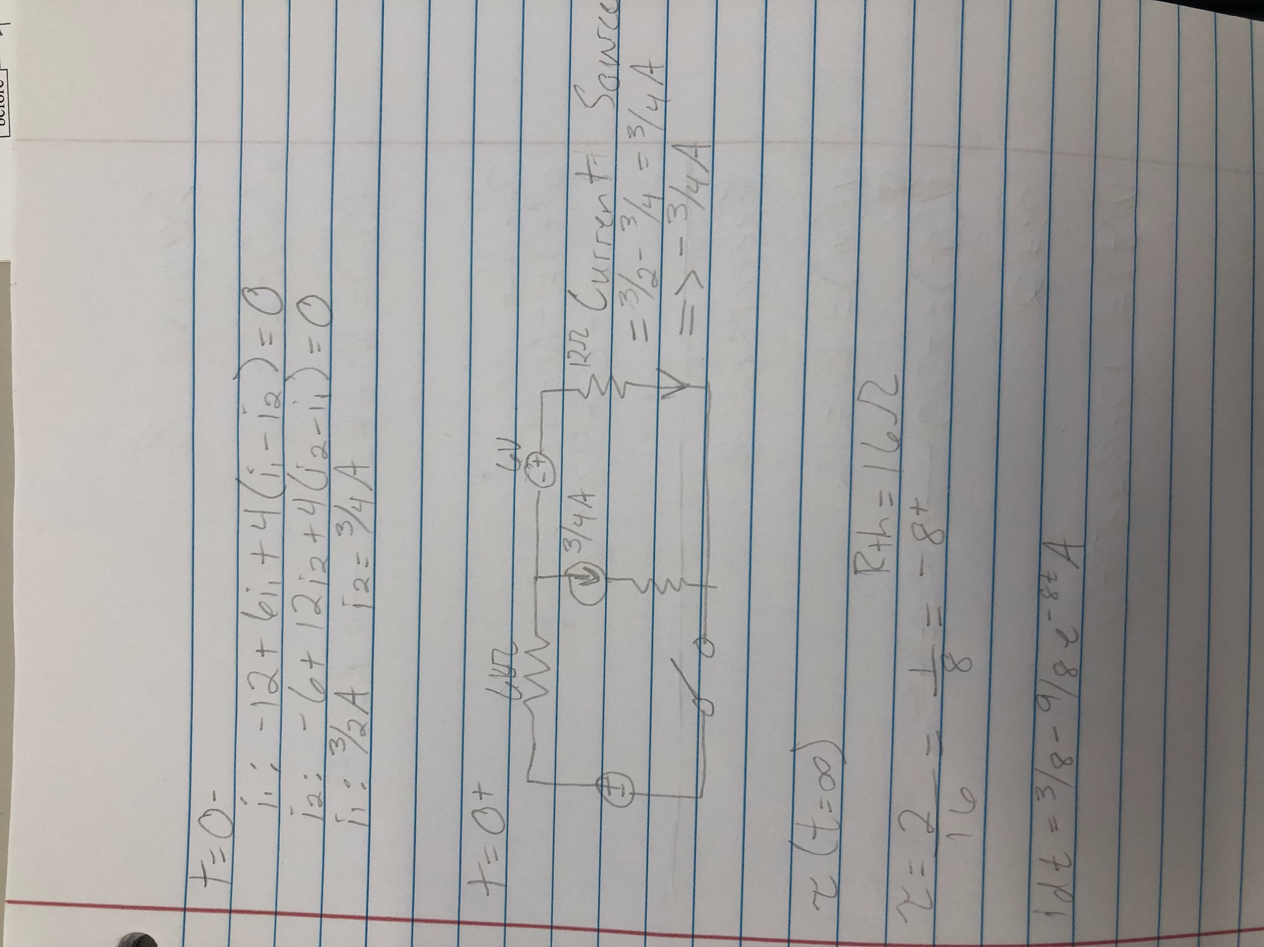

(9)

Continued eqautions

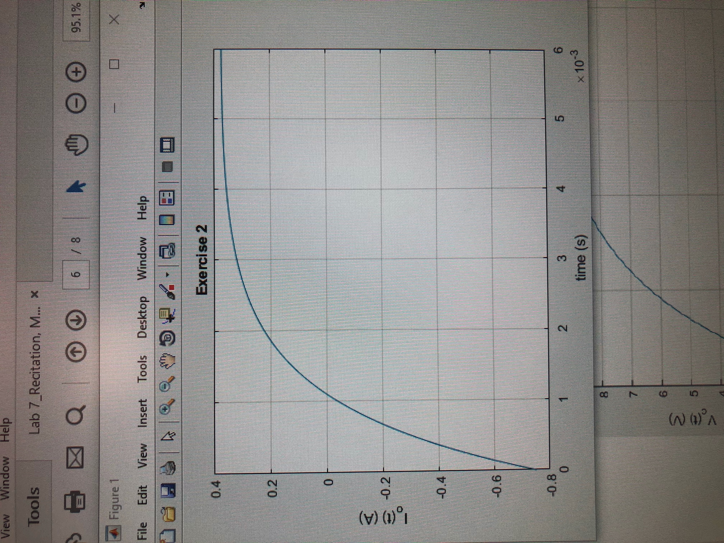

(10)

MATLAB plot

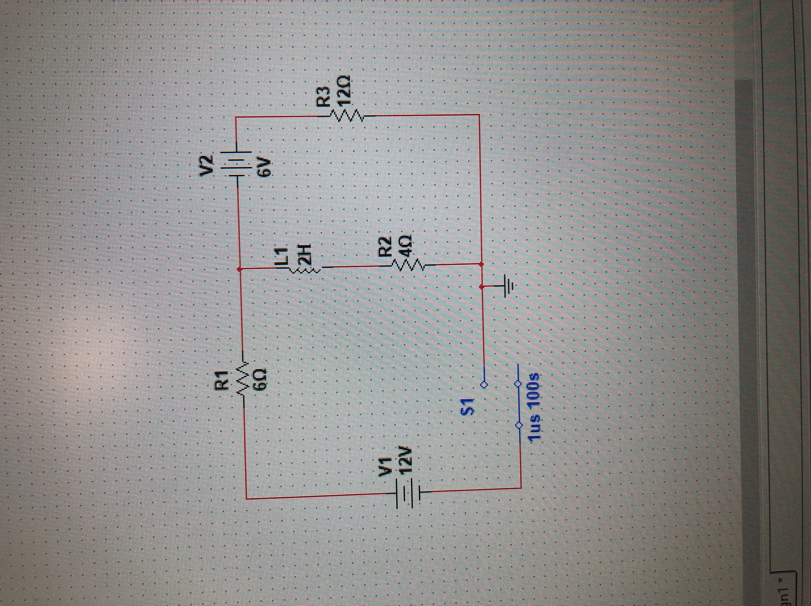

(11)

Schematic in MultiSim

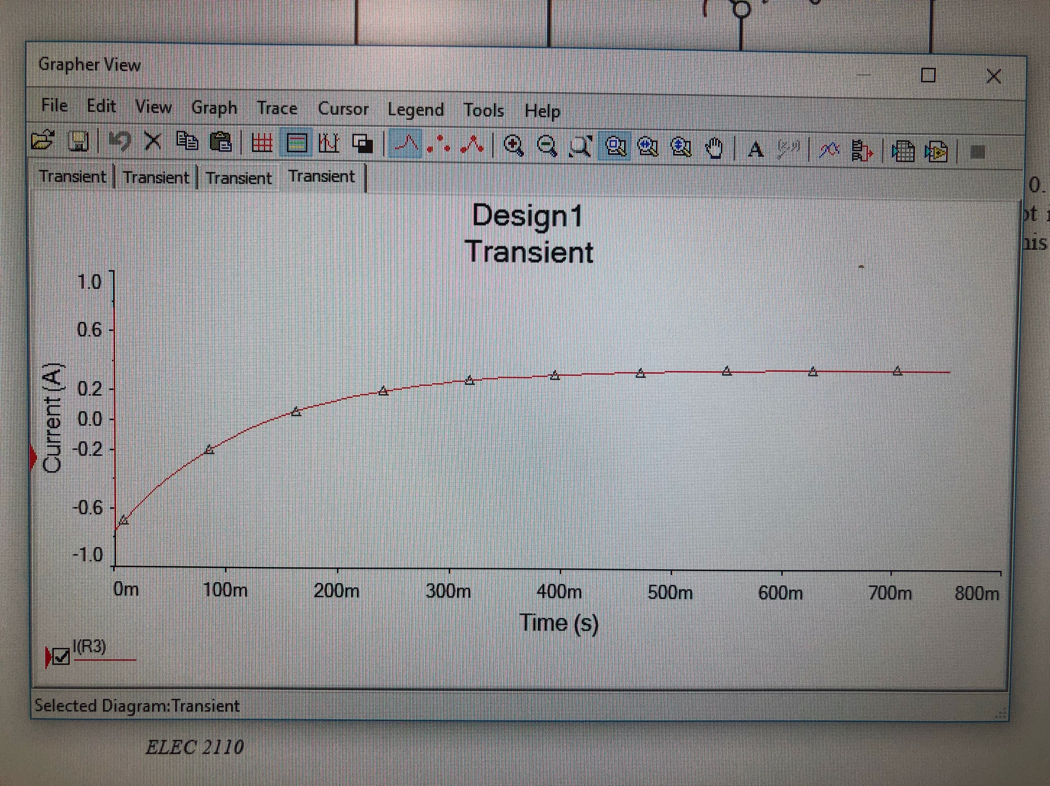

(12)

Graph in MultiSim

Summary Table

|  |  |
| --- | --- |
| K1 | 0.375mA |
| K2 (K1+K2=-0.75) | -1.125mA |
| Rth | 16 Ohm |
| Tau | 0.125 |
| -1/Tau | -8.0 |
| Io(t) | 0.375-1.125e^-8t (A) |

Exercise 3

Given circuit 3, Calculate V0(t) for t > 0. Plot i0(t) versus time using MATLAB and include the plot in your report. Now simulate this circuit using MultiSim and plot V0(t) versus time.

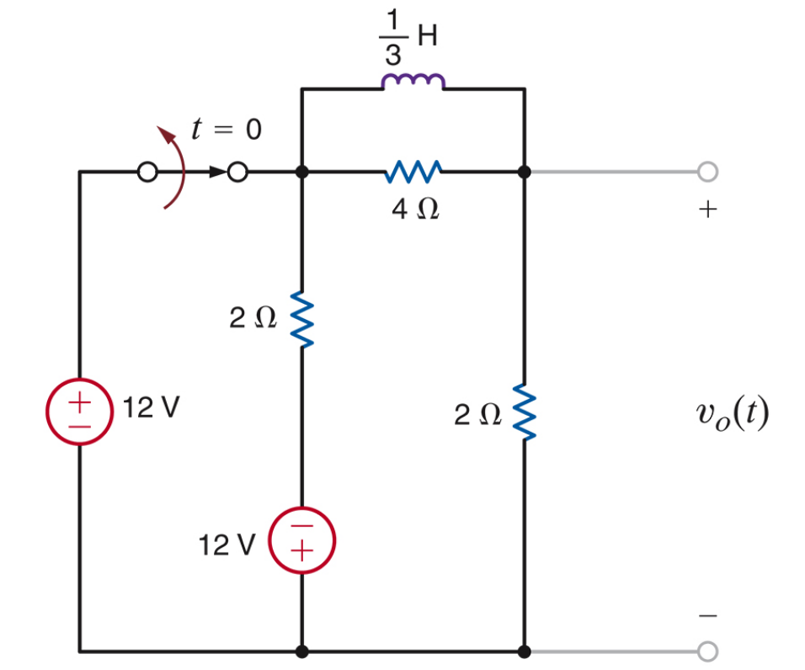

(13)

Circuit 3 for exercise 3

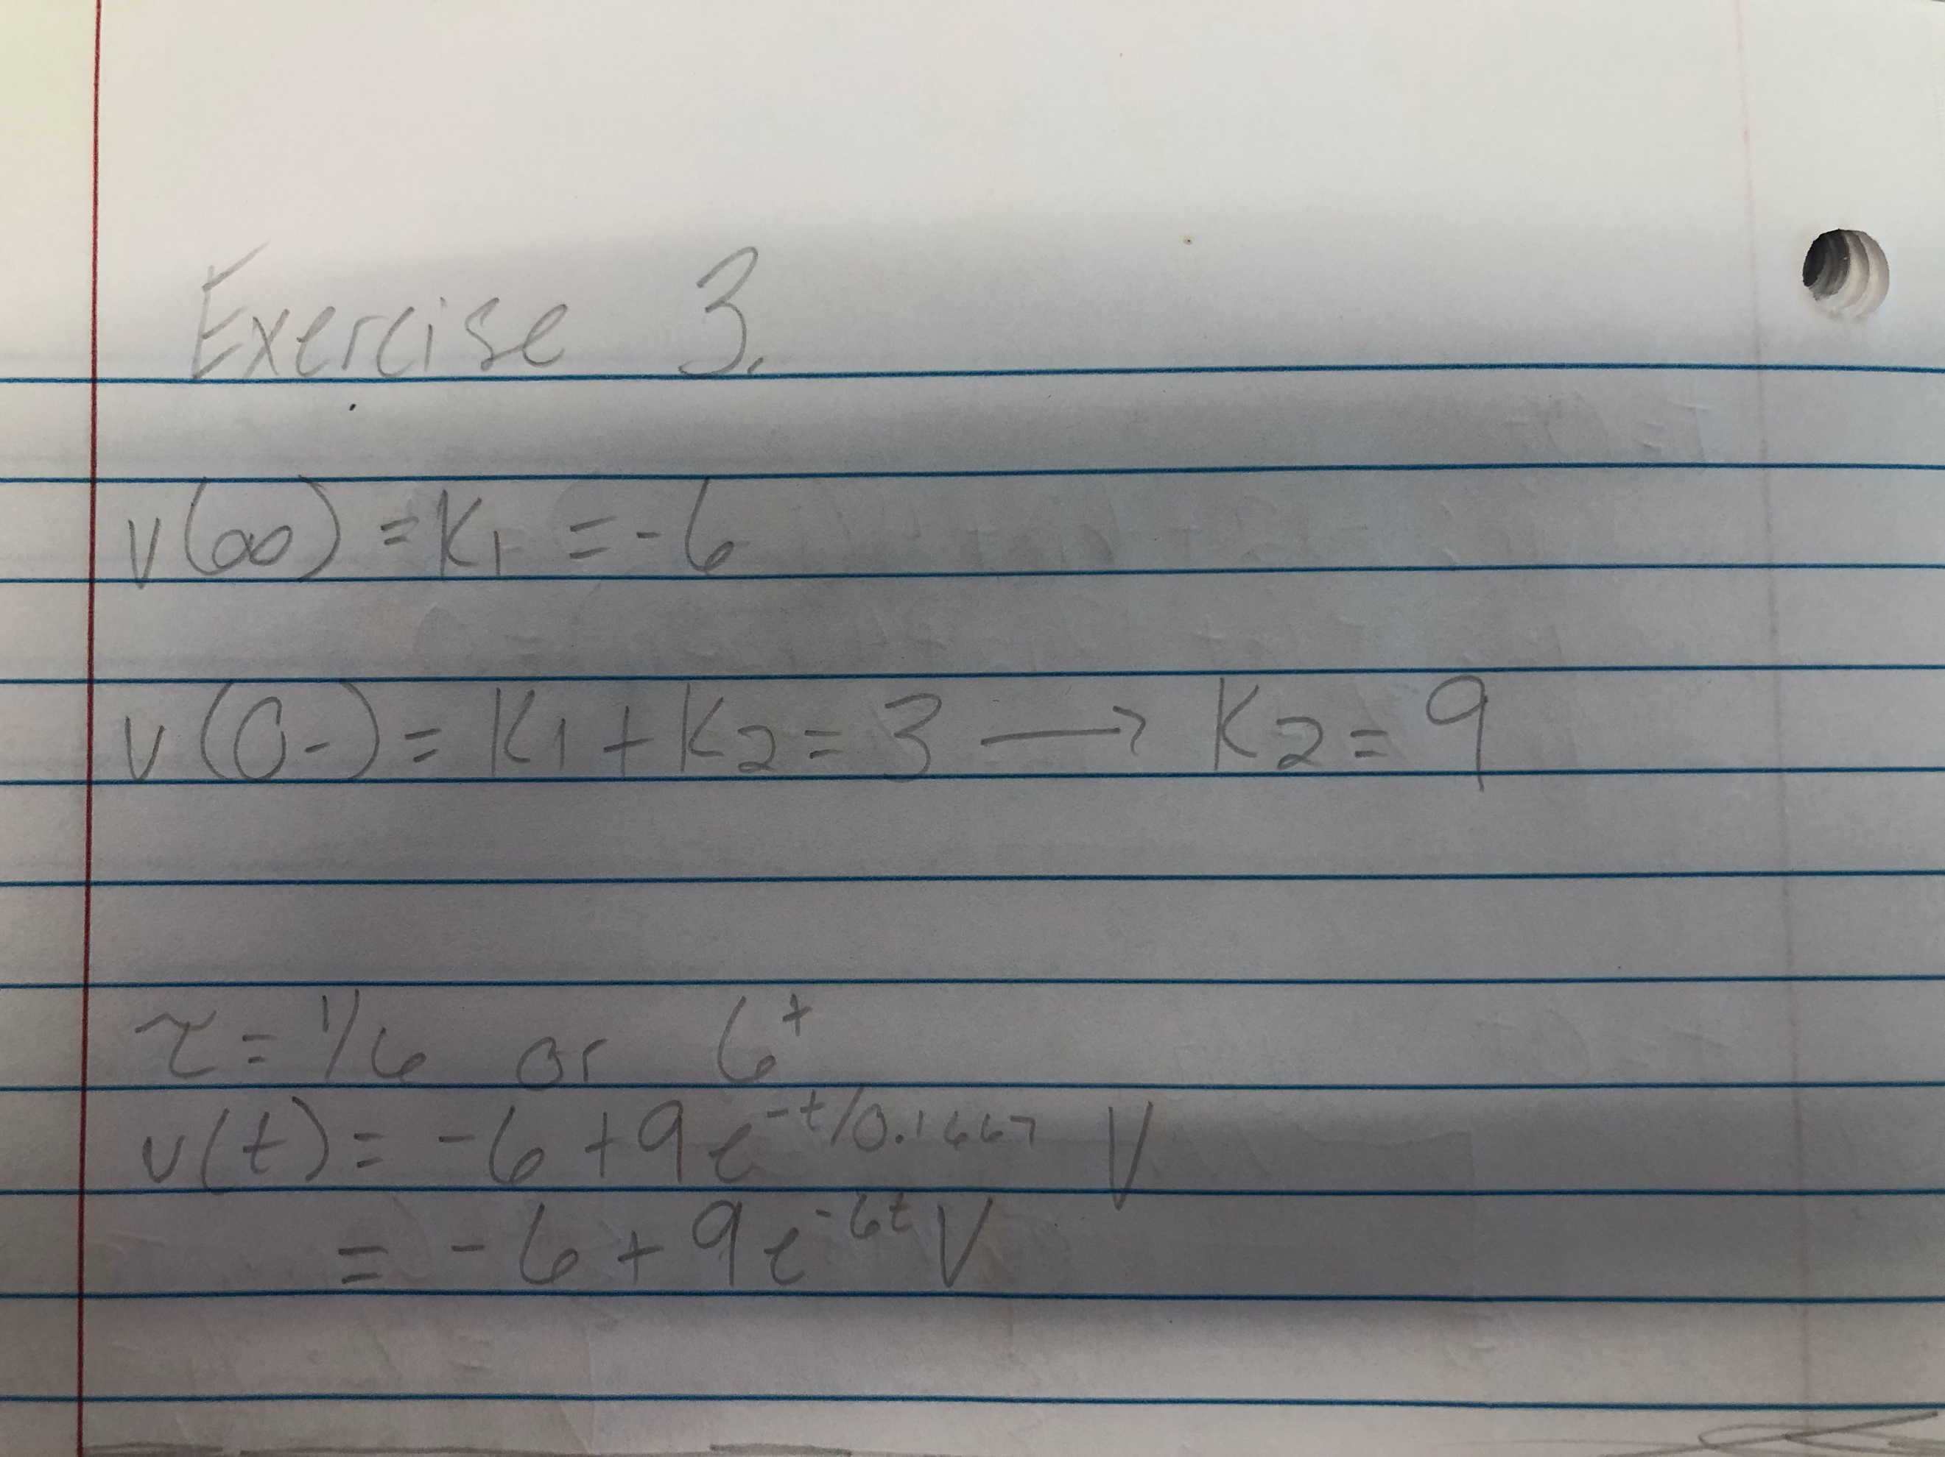

(14)

Equations for exercise 3

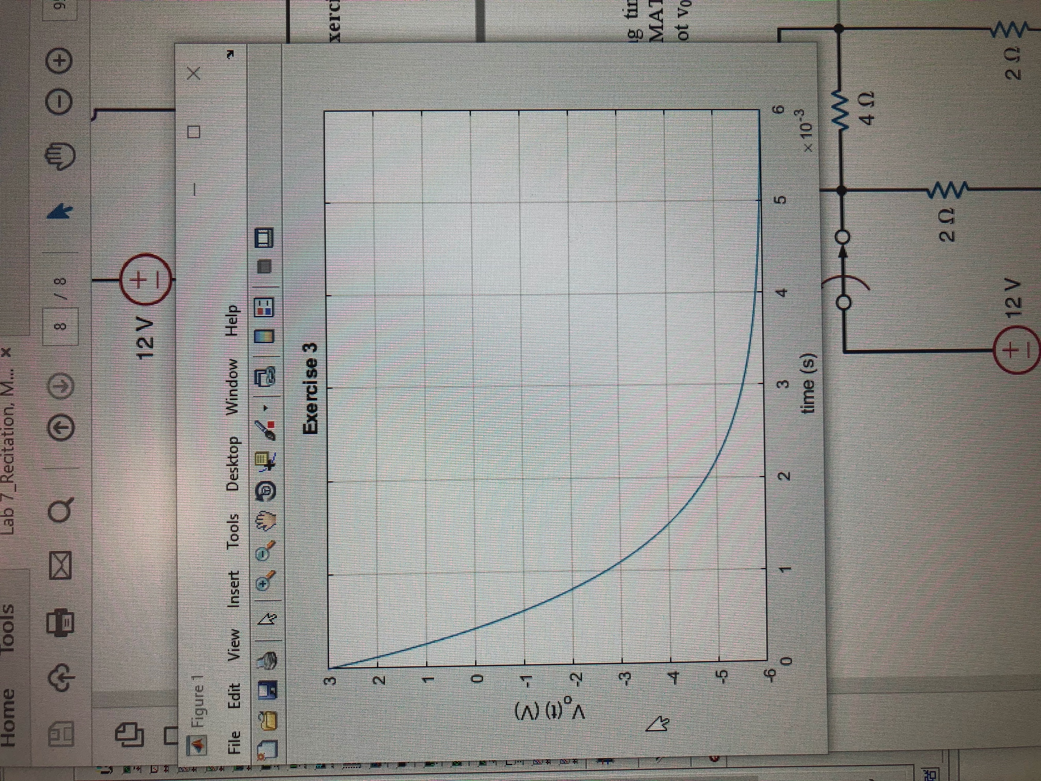

(15)

MATLAB plot

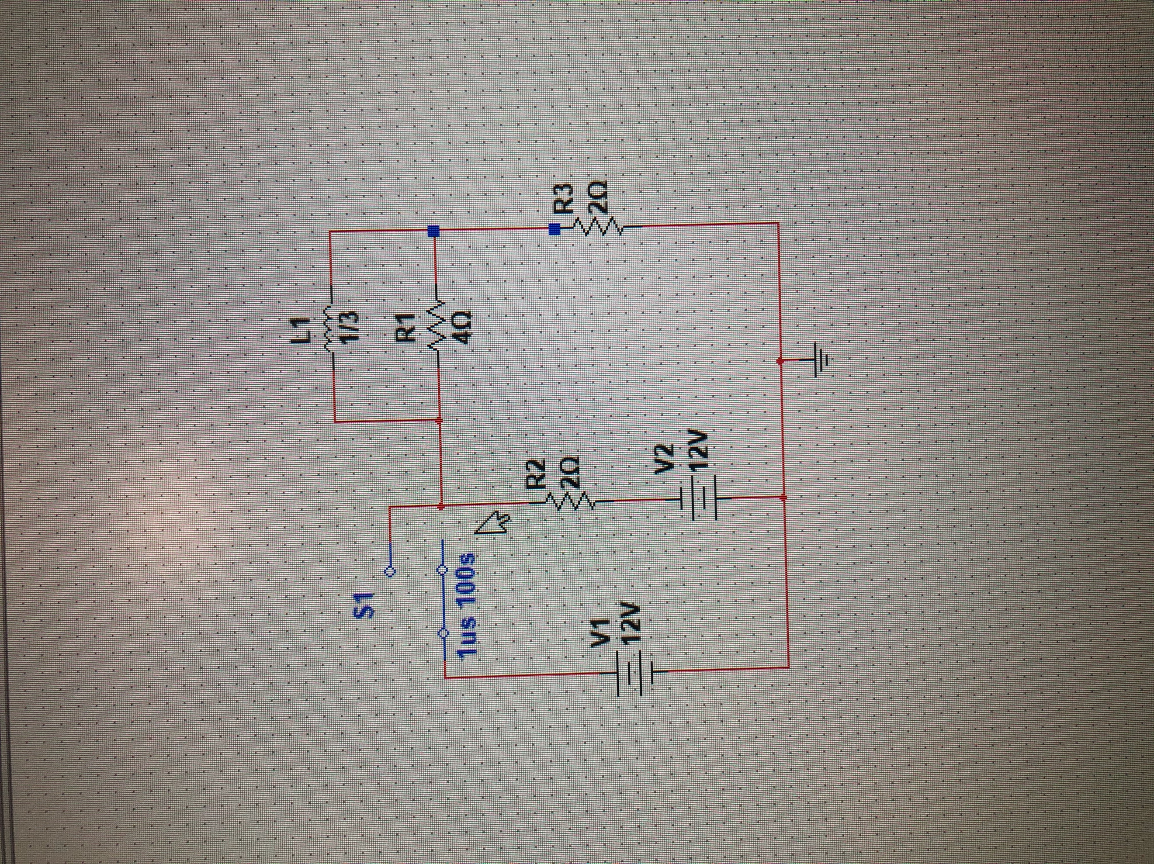

(16)

Schematic for circuit 3

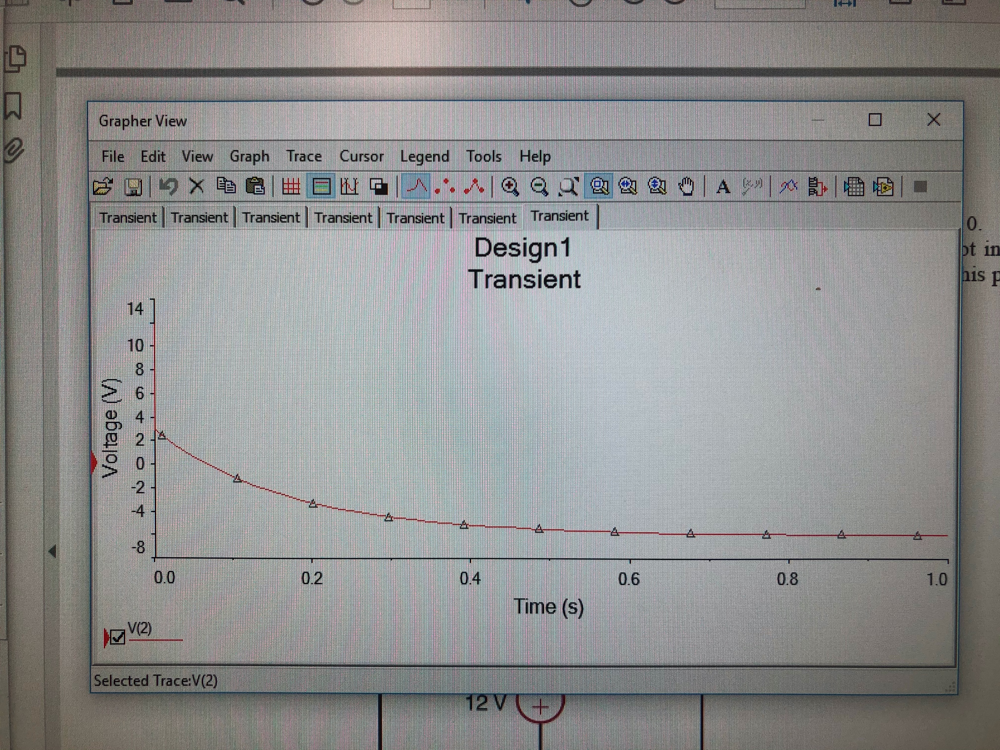

(17)

Graph on MultiSim

Summary Table

|  |  |
| --- | --- |
| K1 | -6.0mA |
| K2 (K1+K2=3.0) | 9.0mA |
| Tau | 0.16667 |
| -1/Tau | -6.0 |
| Vo(t) | -6+9e^-6t (V) |

Exercise 4

Given circuit 4, Calculate V0(t) for t > 0. Plot i0(t) versus time using MATLAB and include the plot in your report. Now simulate this circuit using MultiSim and plot V0(t) versus time.

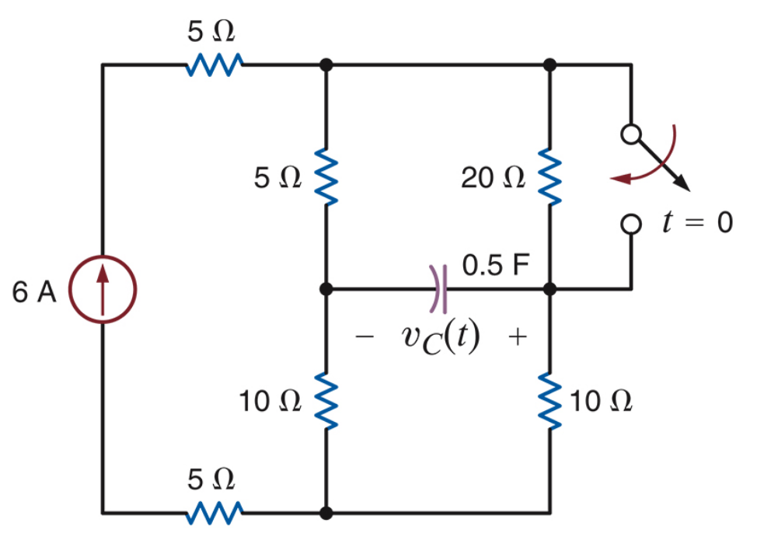

(18)

Circuit 4 for exercise 4

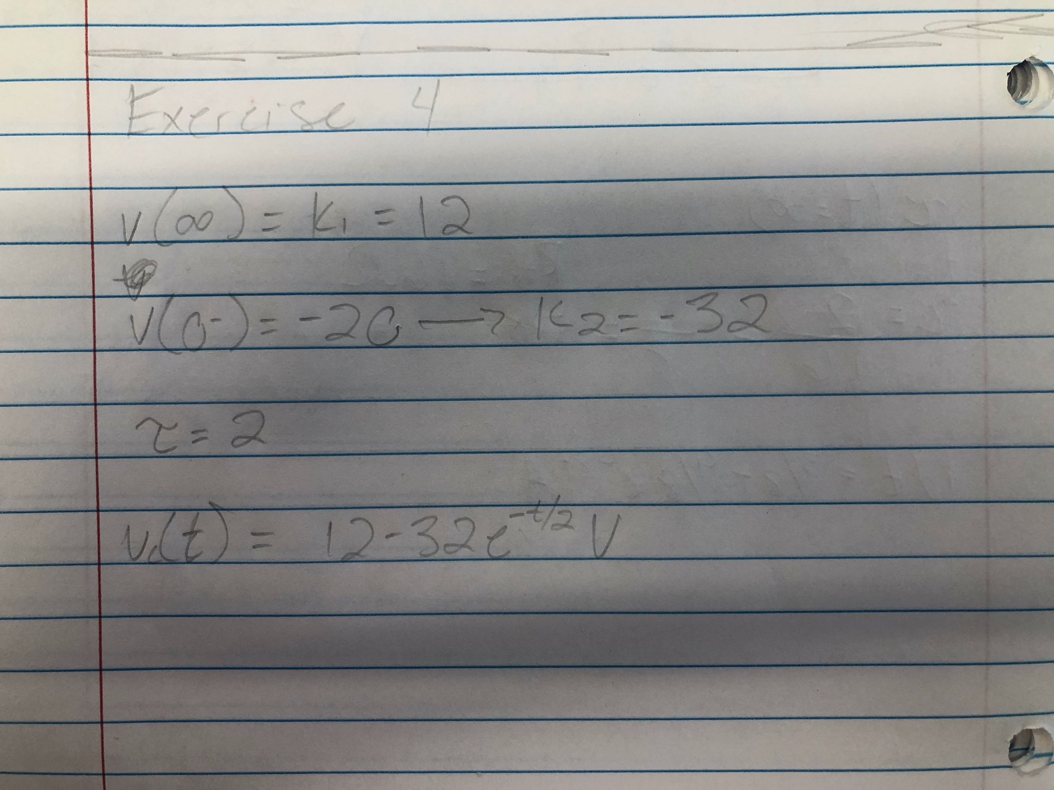

(19)

Equations for exercise 4

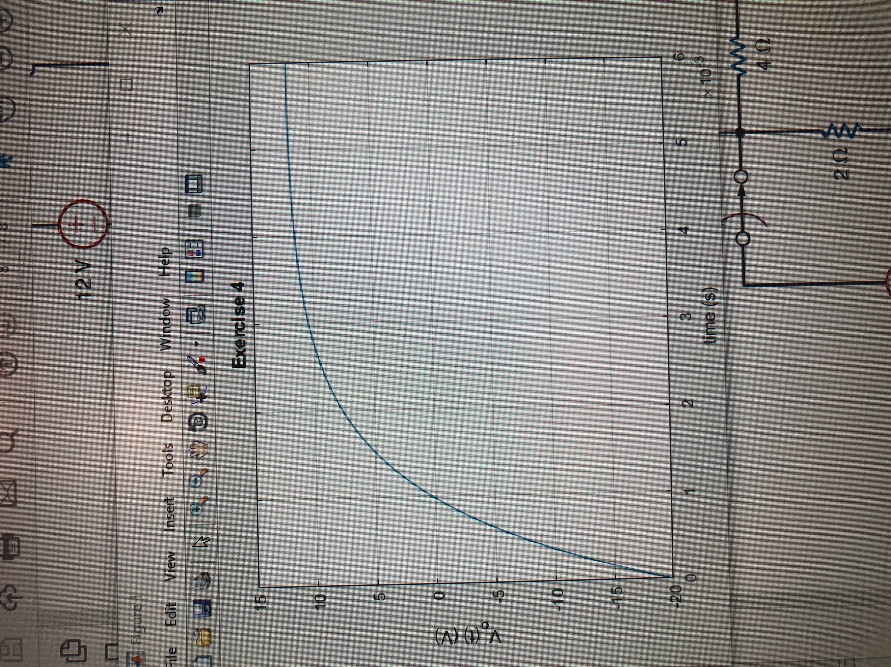

(20)

MATLAB plot

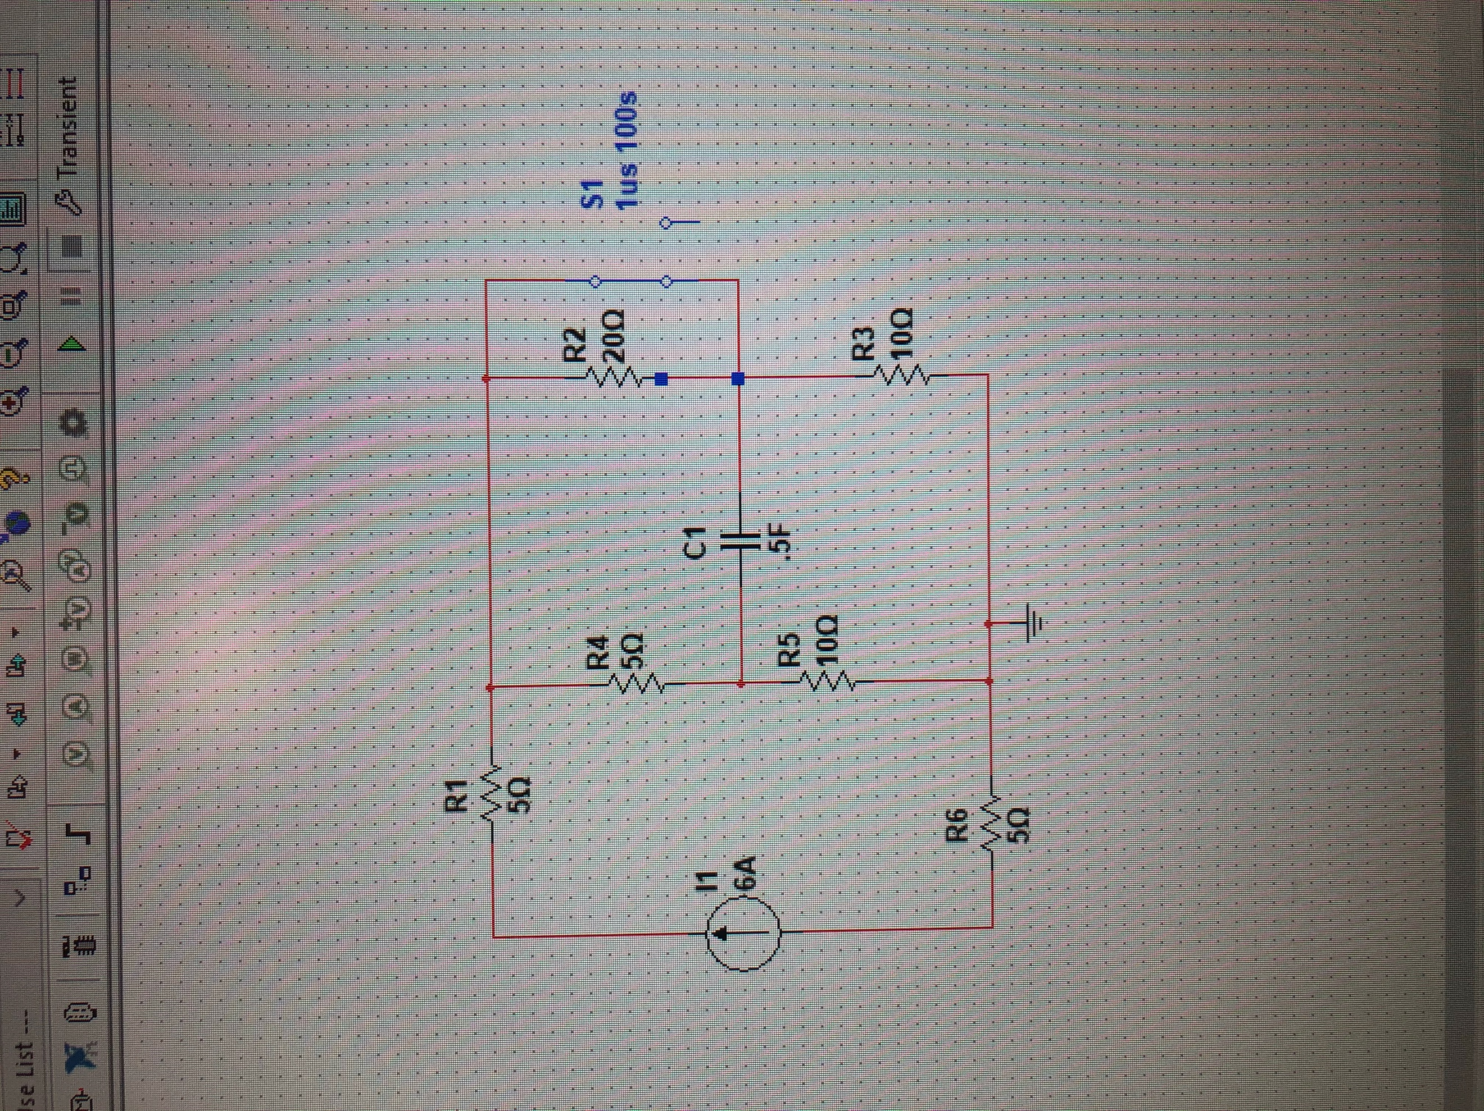

(21)

Schematic for circuit 4

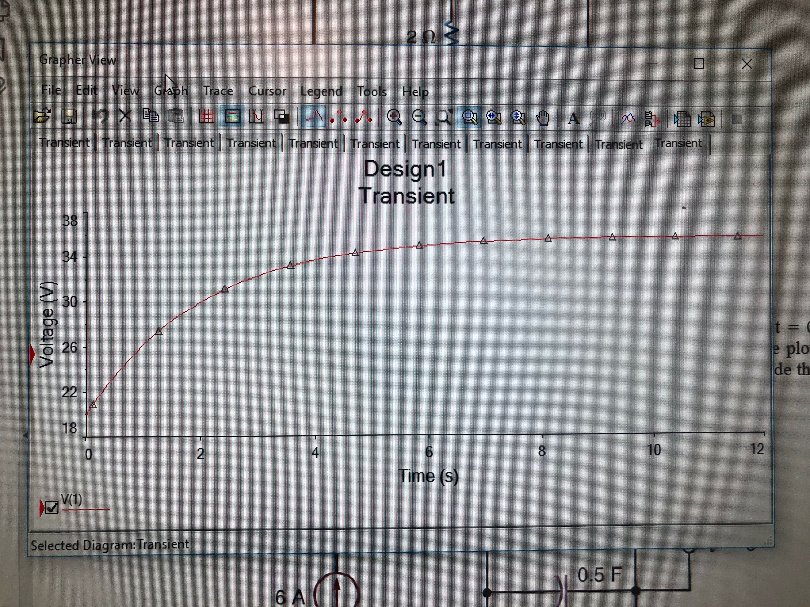

(22)

Graph in MultiSim for exercise 4

Summary Table

|  |  |
| --- | --- |
| K1 | 12.0mA |
| K2 (K1+K2=-20.0) | -32.0mA |
| Tau | 2.0 |
| -1/Tau | 0.5 (or ½) |
| Vo(t) | 12-32e^-t/2 (V) |

Conclusion

This lab is crucial to learning not only how to solve transient circuits, but also in what situations it would be best to solve a circuit, using this method. By the end of the lab the student is much more experienced in this area and should be able to solve almost any transient circuit. This is important since all Electrical Engineers should be able to solve any circuit using the best and most efficient method.

Bibliography

1. Circuit 1 given for exercise 1
2. Equations for exercise 1
3. Continued equations for exercise 1
4. MATLAB plot for exercise 1
5. MultiSim schematic of circuit 1 exercise 1
6. Graph using MultiSim for exercise 1
7. Circuit 2 given for exercise 2
8. Equations for exercise 2
9. Continued equations for exercise 2
10. MATLAB plot for exercise 2
11. MultiSim schematic of circuit 2 exercise 2
12. Graph using MultiSim for exercise 2
13. Circuit 3 given for exercise 3
14. Equations for exercise 3
15. MATLAB plot for exercise 3
16. MultiSim schematic of circuit 3 exercise 3
17. Graph using MultiSim for exercise 3
18. Circuit 4 given for exercise 4
19. Equations for exercise 4
20. MATLAB plot for exercise 4
21. MultiSim schematic of circuit 4 exercise 4
22. Graph using MultiSim for exercise 4